Ryan Libiano

1. Explain the functionality of the FIFO control signals?
   1. 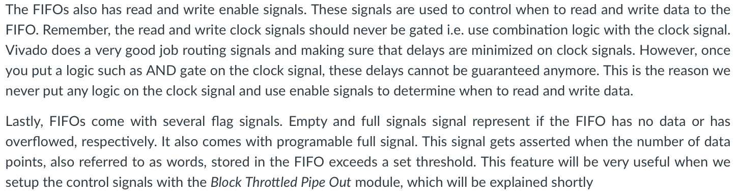
   2. The FIFO has a few control signals. The main ones are to tell it when to read and write. However, there are a few flag signals that help you with the timing of knowing when to do that. The built in flags will tell you when it is done with the following process so that you can avoid going to early and losing data.
2. How can a FIFO overflow happen during data transfer of an image using BTPipeOut?
   1. 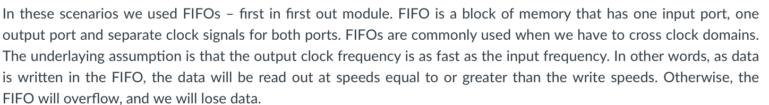
   2. Taken from the lab documentations it is stated that you must read the data faster than you write it or you will write over the previous data before it has time to be read.